Nathan Hale High School Math Invitational
March 15, 2016

SCORE: __________________
Varsity
Event 1: Algebra

Name ___________________________________________

Team ___________________________________ School ____________________________________

ALL ANSWERS MUST BE IN FULLY SIMPLIFIED FORM AND EXACT (unless otherwise stated).

- If 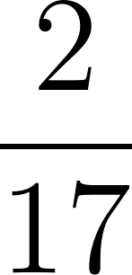 of some number is 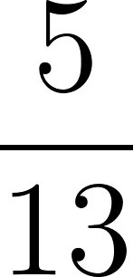 of 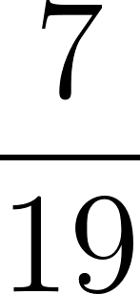 , what is the number expressed as a simplified fraction?

1. ____________________
2 points

- Let 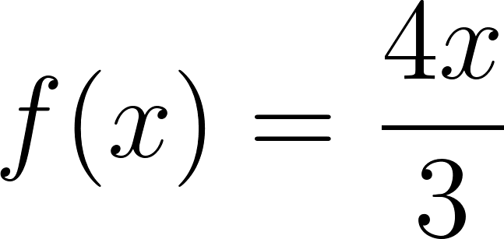 and 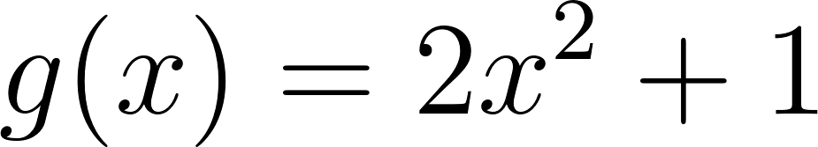. Evaluate 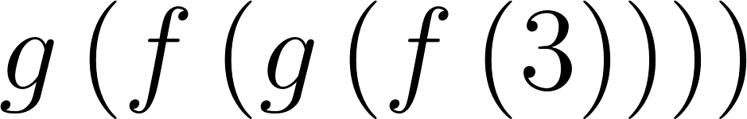

2. ____________________
3 points

- A group of friends stopped by a local restaurant. They decided to put the charges all on one bill. After a short time, two of the friends had to leave in a hurry and didn’t leave their portion of the bill. The total of the bill was $63. One in the group told the others, “Everyone, throw in two dollars extra and we’ll have the bill covered exactly.” How many people were originally in the group?

3. ____________________
5 points

Nathan Hale High School Math Invitational
March 15, 2016

SCORE: __________________
Varsity
Event 2: Geometry

Name ___________________________________________

Team ___________________________________ School ____________________________________

ALL ANSWERS MUST BE IN FULLY SIMPLIFIED FORM AND EXACT (unless otherwise stated).

- Catrina and Tom have a room that measures 14 by 15 feet and want an area rug for the room. They want to leave an even strip of flooring uncovered around the edges of the room. How wide would the strip be if they buy a rectangular rug with an area of 110 square feet?

1. ____________________
2 points

- In the figure below, the circle has center C and radius 6 cm. Segment $\underline{BD}$ is tangent to the circle at D and has length 8 cm. Find the length of segment $\underline{AB}$.
D
2. ____________________
3 points

- What is the smallest possible volume of a cylinder that can completely enclose a sphere of volume 36𝜋 in³ ?
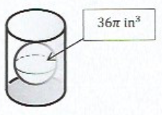 3. ____________________
5 points

Nathan Hale High School Math Invitational
March 15, 2016

SCORE: __________________
Varsity
Event 3: Advanced Math

Name ___________________________________________

Team ___________________________________ School ____________________________________

ALL ANSWERS MUST BE IN FULLY SIMPLIFIED FORM AND EXACT (unless otherwise stated).

- Find the value of x to complete the matrix product:
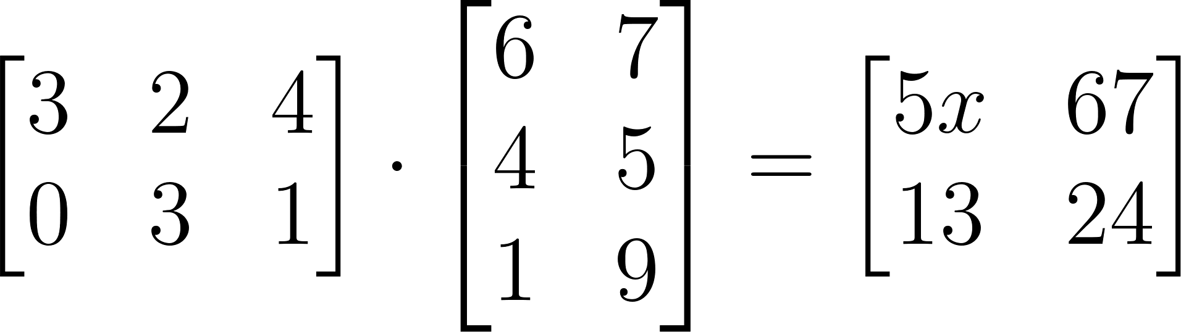

1. ____________________
2 points

- If 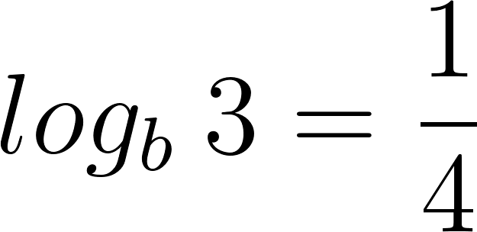 , then what is the value of 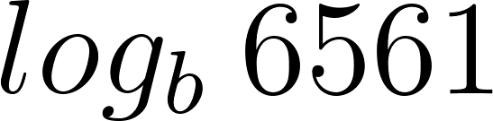 ?

2. ____________________
3 points

- If $sin x=3cos x$, find the numerical value of $(sin x)(cos x)$.

3. ____________________
5 points

Nathan Hale High School Math Invitational
March 15, 2016

SCORE: __________________
Varsity
Event 4: Team

Name ___________________________________________

Team ___________________________________ School ____________________________________

ALL ANSWERS MUST BE IN FULLY SIMPLIFIED FORM AND EXACT (unless otherwise stated).

- In a jar, I have 18 coins worth a total of $2.00. There is at least one quarter, one dime, one nickel, and one penny. What is the probability that if I randomly take out two coins (one at a time, without replacing them) that I would get two nickels?

1. ____________________
10 points

- I wake up if and only if both of my alarm clocks ring at the same time. One clock, which is 3 minutes fast, first rings when it reads 10:14. It then rings every 9 minutes thereafter. The other clock, which is 4 minutes fast, first rings when it reads 10:09. It then rings every 7 minutes thereafter. What will the time actually be when I wake up?

2. ____________________
10 points

- The number $43ab1$ (where $a$ is the digit in the hundreds place and $b$ is the digit in the tens place) is a perfect square. Find the value of $a+b$.

3. ____________________
10 points

- How many positive four-digit integers are divisible by both 4 and by 6?

4. ____________________
10 points

- What is the total number of distinct squares, with sizes ranging from $1×1$ to $4×4$, in the grid below?
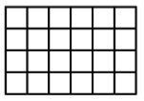

5. ____________________
10 points

- Three circles of radius 1 are tangent to each other so that each circle touches each other circle once. A fourth larger circle is then drawn around these three circles so that it is internally tangent to all three circles. (See below). What is the radius of the largest circle?

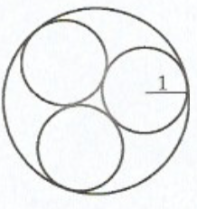

6. ____________________
10 points

